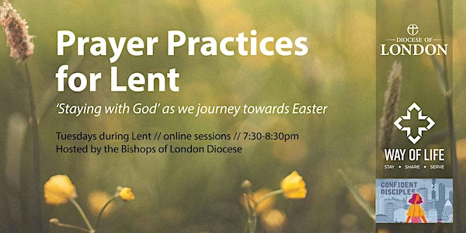
“Lent is a time for discipline, for confession, for honesty, not because God is mean or fault-finding or finger-pointing but because he wants us to know the joy of being cleaned out, ready for all the good things he now has in store.” N. T. Wright
Join us this Lent at St Paul’s. We’re offering a variety of services and events, from simple services and silent meditation to engaging talks with high profile speakers and the full beauty of Anglican liturgy. We hope these resources help you to enter into the mystery of Lent, and draw you closer to Jesus.
All services and events are free and take place at St Paul’s Church, unless stated otherwise.
www.spwh.org
Tuesdays 28 February, 7, 14, 21 and 28 March 7.15pm-8.45pm
Paulin Room, Church Hall

For Lent 2023, the Bishops of London Diocese are hosting five online sessions exploring ancient ways of Christian prayer that are still relevant today and can help us spend time in the presence of God. We’re going to join these as a church live on Tuesday evenings, providing time afterwards to reflect together as a group on the session.

28th February, The Examen
7th March, Lectio Divina
14th March, Centring Prayer
21st March, Imaginative Contemplation
2﻿8th March, Visio Divina (Praying with Pictures)

You can attend some or all of the sessions. It would be helpful if people could sign up by contacting the Parish Office at office@spwh.org or on 020 8886 4290.

Eucharist for Ash Wednesday
The beginning of Lent, and a day set aside for fasting and abstinence as we seek to grow closer to the Lord in this holy season. The Eucharist includes a liturgy of penitence during which we are marked with ash, as a sign of our mortality, and a reminder that we are to trust ourselves to the mercy and compassion of God.
Wednesday 22 February, 12.30pm (said), 8pm (sung)
Midweek Eucharist
Why not make a midweek celebration of Holy Communion part of your Lenten discipline this year? This simple, said service, lasting 25 minutes, including a short homily, fits into your lunchbreak if you’re working from home, and provides a quiet, reflective space in the middle of the week.
Every Wednesday 12.30pm
Choral Evensong for Lent
A service of psalms, readings, canticles and hymns appropriate for the season of Lent, using the exquisitely beautiful language of the Book of Common Prayer, led by St Paul’s Choir. Our guest preacher is the Revd Rich Alldritt, Vicar of St Thomas, Oakwood.
Sunday 5 March 6pm
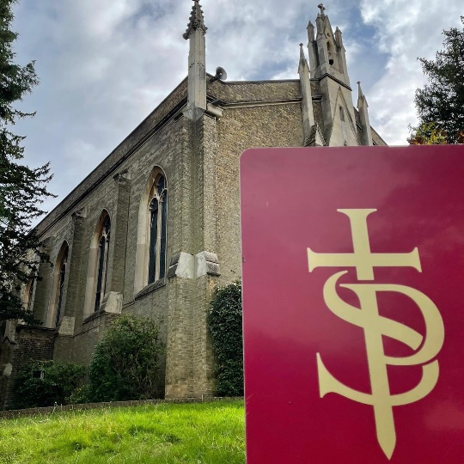
Sunday services
And, of course, we have our usual Sunday services where we meet Jesus in Word and Sacrament. Lent is a good time to make a special effort to attend church each Sunday as we grow together in faith and holiness.
8am Said Eucharist 9.15am Joyful Noise 10.30am Sung Eucharist with children’s groups
Tips for keeping a good Lent
Lent is a period of 40 days, mirroring the 40 days Jesus spent in the wilderness, when we prepare ourselves for the celebration of the Lord’s passion, death and resurrection at Easter. It is a season of penitence and self-denial. Here are few tips for keeping a good Lent:
Fasting: Ash Wednesday and the Fridays of Lent are days of fasting and abstinence. It’s traditional to eat and drink sparingly on these days, and to miss a main meal. Donate the money you save to charity. (Children, pregnant women and those with health needs shouldn’t fast unless it’s safe to do so.)
Make your confession: Some people find the practice of confessing their sins in the presence of a priest, and receiving sacramental absolution, a helpful way of ‘spring-cleaning the soul’ during Lent. Contact Fr Daniel to make an appointment, or he can put you in touch with another priest if you’d rather make your confession to someone you don’t know.
Give something up / take something up: Lots of people give something up for Lent. Make sure it’s something which helps you grow in your faith. Use the time and money you would have spent to help you grow in discipleship, and/or to help those in need. You could take something up to replace that which you have given up.
Lent appeal
The Diocese of London’s 2023 Lent Appeal will raise money to train leaders in Mozambique who can provide pastoral care and support for those with trauma.
Since 2017, over a million people living in northern Mozambique have been displaced by a violent insurgency and 4,000 have been killed. This is a population now who are deeply traumatised. Many professionals have said that their need for trauma counselling and support is as great as their need for food, but agencies and organisations do not have funds for this.
To find out more or donate to the appeal please visit: london.anglican.org/lentappeal2023

